**East West University**

**Course Code & Name: CSE 302 (Database Systems)**

**Course Instructor: Sanzana Karim Lora**

**Course Section: 10**

**Academic Session: Summer 2025**

**Project Report**

**Group No.- 03**

**Group Members:**

|  |  |  |
| --- | --- | --- |
| **Name** | **Id** | **Contribution** |
| Md. Abir Rahman | 2023-3-60-223 | 25% |
| Md Julfiker Hossain | 2023-3-60-490 | 25% |
| Sudeepta Mandal | 2023-3-60-222 | 25% |
| Md. Rashid Uz Zaman | 2023-3-60-195 | 25% |

**Project Title:**

**\*\*BPL DataVault : A BPL Database Management System\*\***

**Submission Date & Day: September 04, 2025 (Thursday)**

**Table of Contents**

|  |  |
| --- | --- |
| **Topic** | **Page No.** |
| ER- Model: Relational Diagram | 03 |
| Implementation Checklist | 04 |
| Normalization | 05-14 |
| Pages | 15-42 |
| Authorization and User Role Assignment | 42 |
| Page-Wise Authorization Information | 43 |
| Conclusion | 45 |

**ER- Model: Relational Diagram:**

**Implementation Checklist:**

|  |  |
| --- | --- |
| **Description** | **Remarks** |
| Project ID | 14889 |
| Workspace Name | Sakin_Workspace |
| Workspace Email | [abirrahman.sakin@gmail.com](mailto:abirrahman.sakin@gmail.com(main)) |
| Workspace Password | #spsakin@329 |
| Authentication Type | Custom |
| Username and Password to Login | User: sakin (Administrator)  Password: lion  User: julfiker (Administrator)  Password: monkey  User: sudeep (Administrator)  Password: sheep  User: rashed (Administrator)  Password: rashed |
| User: thor (Contributor)  Password: loki |
| User: messi (reader)  Password: goat  User: neymar (reader)  Password: goat  User: ronaldo (reader)  Password: goat |
| Uploaded and Displayed Images in Reports | yes |
| Implemented Page-wise Authorization | yes |
| Number of Total Pages | 51 |
| Number of Reports with Forms | 34 |
| Number of Reports based on Queries, Aggregate Queries | 13 |
| Number of Graphs/Charts | 9 |

**Normalization:**

***1. Team***

|  |  |  |
| --- | --- | --- |
| Column Name | Data Type | Constraints |
| TeamName | VARCHAR2 | NOT NULL, PRIMARY KEY |
| TeamLogo | BLOB |  |

***Team table is in BCNF.***

***Primary Key:*** TeamName

***Non-Key columns:*** TeamLogo, Mime_Type, File_Type, Updated_Date.

***Functional Dependencies:***

TeamName → TeamLogo, Mime_Type, File_Type, Updated_Date

***BCNF Check:***

* **1NF (First Normal Form):** All columns contain atomic values, no repeating groups.
* **No Partial Dependencies:** No partial dependencies exist; table satisfies **2NF**.
* **No Transitive Dependencies:** No non-key attribute depends on another non-key attribute; satisfies **3NF**.
* **BCNF Rule:** All functional dependencies have candidate keys on **LHS.**

***2. Venue***

|  |  |  |
| --- | --- | --- |
| Column Name | Data Type | Constraints |
| VenueName | VARCHAR2 | NOT NULL, PRIMARY KEY |
| VenuePic | BLOB |  |
| CityName | VARCHAR2 |  |

***Venue table is in BCNF.***

***Primary Key***: VenueName

***Non-Key columns:*** VenuePic, Mime_Type, File_Type, Updated_Date, CityName.

**Functional Dependencies:**

VenueName → VenuePic, Mime_Type, File_Type, Updated_Date, CityName

***BCNF Check:***

* **1NF (First Normal Form):** All columns contain atomic values, no repeating groups.
* **No Partial Dependencies:** No partial dependencies exist; table satisfies **2NF**.
* **No Transitive Dependencies:** No non-key attribute depends on another non-key attribute; satisfies **3NF**.
* **BCNF Rule:** All functional dependencies have candidate keys on **LHS.**

***3. Match***

|  |  |  |
| --- | --- | --- |
| Column Name | Data Type | Constraints |
| MatchID | NUMBER | NOT NULL, PRIMARY KEY |
| MatchType | VARCHAR2 |  |
| MatchDate | DATE |  |
| Team1 | VARCHAR2 |  |
| Team2 | VARCHAR2 |  |
| VenueName | VARCHAR2 |  |
| SeasonYear | VARCHAR2 |  |
| Method | VARCHAR2 |  |

***Match table is in BCNF.***

***Primary Key:*** MatchID

***Non-Key columns***: MatchType, MatchDate, Team1, Team2, VenueName, SeasonYear, Method.

***Functional Dependencies:***

MatchID → MatchType, MatchDate, Team1, Team2, VenueName, SeasonYear, Method

***BCNF Check:***

* **1NF (First Normal Form):** All columns contain atomic values, no repeating groups.
* **No Partial Dependencies:** No partial dependencies exist; table satisfies **2NF**.
* **No Transitive Dependencies:** No non-key attribute depends on another non-key attribute; satisfies **3NF**.
* **BCNF Rule:** All functional dependencies have candidate keys on **LHS.**

***4. Player***

|  |  |  |
| --- | --- | --- |
| Column Name | Data Type | Constraints |
| PlayerID | NUMBER | NOT NULL, PRIMARY KEY |
| PlayerName | VARCHAR2 |  |

***Player table is in BCNF.***

***Primary Key***: PlayerID

***Non-Key columns***: PlayerName.

***Functional Dependencies:***

PlayerID → PlayerName

BCNF Check:

* **1NF (First Normal Form):** All columns contain atomic values, no repeating groups.
* **No Partial Dependencies:** No partial dependencies exist; table satisfies **2NF**.
* **No Transitive Dependencies:** No non-key attribute depends on another non-key attribute; satisfies **3NF**.
* **BCNF Rule:** All functional dependencies have candidate keys on **LHS.**

***5. Season***

|  |  |  |
| --- | --- | --- |
| Column Name | Data Type | Constraints |
| SeasonYear | VARCHAR2 | NOT NULL, PRIMARY KEY |
| PlayerOfTheTournament | VARCHAR2 |  |

***Season table is in BCNF.***

***Primary Key:*** SeasonYear

***Non-Key columns:*** PlayerOfTheTournament.

***Functional Dependencies:***

SeasonYear → PlayerOfTheTournament

***BCNF Check:***

* **1NF (First Normal Form):** All columns contain atomic values, no repeating groups.
* **No Partial Dependencies:** No partial dependencies exist; table satisfies **2NF**.
* **No Transitive Dependencies:** No non-key attribute depends on another non-key attribute; satisfies **3NF**.
* **BCNF Rule:** All functional dependencies have candidate keys on **LHS.**

***6. Season_Team_Player***

|  |  |  |
| --- | --- | --- |
| Column Name | Data Type | Constraints |
| PlayerID | NUMBER | PRIMARY KEY |
| TeamName | VARCHAR2 | PRIMARY KEY |
| SeasonYear | VARCHAR2 | PRIMARY KEY |

***Season_Team_Player table is in BCNF.***

***Primary Key***: (PlayerID, TeamName, SeasonYear)

***Non-Key columns***: None.

***Functional Dependencies:***

No non-key attributes

***BCNF Check:***

* **1NF (First Normal Form):** All columns contain atomic values, no repeating groups.
* **No Partial Dependencies:** No partial dependencies exist; table satisfies **2NF**.
* **No Transitive Dependencies:** No non-key attribute depends on another non-key attribute; satisfies **3NF**.
* **BCNF Rule:** All functional dependencies have candidate keys on **LHS.**

***7. Umpire***

|  |  |  |
| --- | --- | --- |
| Column Name | Data Type | Constraints |
| UmpireID | NUMBER | NOT NULL, PRIMARY KEY |
| UmpireName | VARCHAR2 |  |

**Umpire table is in BCNF.**

***Primary Key***: UmpireID

***Non-Key columns***: UmpireName.

***Functional Dependencies:***

UmpireID → UmpireName

***BCNF Check:***

* **1NF (First Normal Form):** All columns contain atomic values, no repeating groups.
* **No Partial Dependencies:** No partial dependencies exist; table satisfies **2NF**.
* **No Transitive Dependencies:** No non-key attribute depends on another non-key attribute; satisfies **3NF**.
* **BCNF Rule:** All functional dependencies have candidate keys on **LHS.**

***8. Umpired_By***

|  |  |  |
| --- | --- | --- |
| Column Name | Data Type | Constraints |
| MatchID | NUMBER | PRIMARY KEY |
| UmpireID | NUMBER | PRIMARY KEY |

***Umpired_By table is in BCNF.***

***Primary Key***: (MatchID, UmpireID)

***Non-Key columns***: None.

***Functional Dependencies:***

No non-key attributes

***BCNF Check:***

* **1NF (First Normal Form):** All columns contain atomic values, no repeating groups.
* **No Partial Dependencies:** No partial dependencies exist; table satisfies **2NF**.
* **No Transitive Dependencies:** No non-key attribute depends on another non-key attribute; satisfies **3NF**.
* **BCNF Rule:** All functional dependencies have candidate keys on **LHS.**

***9. Toss***

|  |  |  |
| --- | --- | --- |
| Column Name | Data Type | Constraints |
| MatchID | NUMBER | NOT NULL, PRIMARY KEY |
| TossWinner | VARCHAR2 |  |
| TossDecision | VARCHAR2 |  |

***Toss table is in BCNF.***

***Primary Key***: MatchID

***Non-Key columns***: TossWinner, TossDecision.

***Functional Dependencies:***

MatchID → TossWinner, TossDecision

***BCNF Check:***

* **1NF (First Normal Form):** All columns contain atomic values, no repeating groups.
* **No Partial Dependencies:** No partial dependencies exist; table satisfies **2NF**.
* **No Transitive Dependencies:** No non-key attribute depends on another non-key attribute; satisfies **3NF**.
* **BCNF Rule:** All functional dependencies have candidate keys on **LHS.**

**10. ScoredRuns**

|  |  |  |
| --- | --- | --- |
| Column Name | Data Type | Constraints |
| OverNO | NUMBER | PRIMARY KEY |
| Ball_NO | NUMBER | PRIMARY KEY |
| InningsNo | NUMBER | PRIMARY KEY |
| MatchID | NUMBER | PRIMARY KEY |
| RunScored | NUMBER |  |

***ScoredRuns table is in BCNF.***

***Primary Key***: (OverNO, Ball_NO, InningsNo, MatchID)

***Non-Key columns***: RunScored.

***Functional Dependencies:***

(OverNO, Ball_NO, InningsNo, MatchID) → RunScored

***BCNF Check:***

* **1NF (First Normal Form):** All columns contain atomic values, no repeating groups.
* **No Partial Dependencies:** No partial dependencies exist; table satisfies **2NF**.
* **No Transitive Dependencies:** No non-key attribute depends on another non-key attribute; satisfies **3NF**.
* **BCNF Rule:** All functional dependencies have candidate keys on **LHS.**

**11. MatchResult**

|  |  |  |
| --- | --- | --- |
| Column Name | Data Type | Constraints |
| MatchID | NUMBER | NOT NULL, PRIMARY KEY |
| MatchWinner | VARCHAR2 |  |
| WinType | VARCHAR2 |  |
| WinMargin | VARCHAR2 |  |
| ManOfTheMatch | VARCHAR2 |  |

***MatchResult table is in BCNF.***

***Primary Key***: MatchID

***Non-Key columns***: MatchWinner, WinType, WinMargin, ManOfTheMatch.

***Functional Dependencies:***

MatchID → MatchWinner, WinType, WinMargin, ManOfTheMatch

***BCNF Check:***

* **1NF (First Normal Form):** All columns contain atomic values, no repeating groups.
* **No Partial Dependencies:** No partial dependencies exist; table satisfies **2NF**.
* **No Transitive Dependencies:** No non-key attribute depends on another non-key attribute; satisfies **3NF**.
* **BCNF Rule:** All functional dependencies have candidate keys on **LHS.**

**12. ExtraRuns**

|  |  |  |
| --- | --- | --- |
| Column Name | Data Type | Constraints |
| OverNO | NUMBER | PRIMARY KEY |
| Ball_NO | NUMBER | PRIMARY KEY |
| InningsNo | NUMBER | PRIMARY KEY |
| MatchID | NUMBER | PRIMARY KEY |
| ExtraType | VARCHAR2 |  |
| ExtraRuns | NUMBER |  |

***ExtraRuns table is in BCNF.***

***Primary Key***: (OverNO, Ball_NO, InningsNo, MatchID)

***Non-Key columns***: ExtraType, ExtraRuns.

***Functional Dependencies:***

(OverNO, Ball_NO, InningsNo, MatchID) → ExtraType, ExtraRuns

***BCNF Check:***

* **1NF (First Normal Form):** All columns contain atomic values, no repeating groups.
* **No Partial Dependencies:** No partial dependencies exist; table satisfies **2NF**.
* **No Transitive Dependencies:** No non-key attribute depends on another non-key attribute; satisfies **3NF**.
* **BCNF Rule:** All functional dependencies have candidate keys on **LHS.**

**13. Ball_By_Ball**

|  |  |  |
| --- | --- | --- |
| Column Name | Data Type | Constraints |
| OverNO | NUMBER | PRIMARY KEY |
| Ball_NO | NUMBER | PRIMARY KEY |
| InningsNo | NUMBER | PRIMARY KEY |
| MatchID | NUMBER | PRIMARY KEY |
| TeamBatting | VARCHAR2 |  |
| Team_Bowling | VARCHAR2 |  |
| Striker | NUMBER |  |
| Non-Striker | NUMBER |  |
| Bowler | NUMBER |  |

***Ball_By_Ball table is in BCNF.***

***Primary Key***: (OverNO, Ball_NO, InningsNo, MatchID)

**Non-Key columns**: TeamBatting, Team_Bowling, Striker, Non-Striker, Bowler.

**Functional Dependencies:**

(OverNO, Ball_NO, InningsNo, MatchID) → TeamBatting, Team_Bowling, Striker, Non-Striker, Bowler

**BCNF Check:**

* **1NF (First Normal Form):** All columns contain atomic values, no repeating groups.
* **No Partial Dependencies:** No partial dependencies exist; table satisfies **2NF**.
* **No Transitive Dependencies:** No non-key attribute depends on another non-key attribute; satisfies **3NF**.
* **BCNF Rule:** All functional dependencies have candidate keys on **LHS.**

**14. WicketTaken**

|  |  |  |
| --- | --- | --- |
| Column Name | Data Type | Constraints |
| OverNO | NUMBER | PRIMARY KEY |
| Ball_NO | NUMBER | PRIMARY KEY |
| InningsNo | NUMBER | PRIMARY KEY |
| MatchID | NUMBER | PRIMARY KEY |
| PlayerOut | VARCHAR2 |  |
| Fielder | VARCHAR2 |  |
| OutType | VARCHAR2 |  |

***WicketTaken table is in BCNF.***

***Primary Key***: (OverNO, Ball_NO, InningsNo, MatchID)

***Non-Key columns***: PlayerOut, Fielder, OutType.

**Functional Dependencies:**

(OverNO, Ball_NO, InningsNo, MatchID) → PlayerOut, Fielder, OutType

***BCNF Check:***

* • 1NF (First Normal Form): All columns contain atomic values, no repeating groups.
* • No Partial Dependencies: No partial dependencies exist; table satisfies 2NF.
* • No Transitive Dependencies: No non-key attribute depends on another non-key attribute; satisfies 3NF.
* • BCNF Rule: All functional dependencies have candidate keys on LHS.

**Pages:**

|  |  |  |
| --- | --- | --- |
| **Report Page Number and Name** | **Form Page Number and Name** | **Table** |
| 2. Ball_By_Ball | 3. Ball_By_Ball Form | Ball_By_Ball |
| 4. ExtraRuns | 5. ExtraRuns Form | ExtraRuns |
| 6. Match | 7. Match Form | Match |
| 8. MatchResult | 9. MatchResult Form | MatchResult |
| 10. Player | 11. Player Form | Player |
| 12. ScoredRuns | 13. ScoredRuns Form | ScoredRuns |
| 14. Season | 15. Season Form | Season |
| 16. Season_Team_Player | 17. Season_Team_Player Form | Season_Team_Player |
| 18. Team | 19. Team Form | Team |
| 20. Toss | 21. Toss Form | Toss |
| 22. Umpire | 23. Umpire Form | Umpire |
| 24. UmpiredBy | 25. UmpiredBy Form | UmpiredBy |
| 26. Venue | 27. Venue Form | Venue |
| 28. WicketTaken | 29. WicketTaken Form | WicketTaken |

**Login page:**

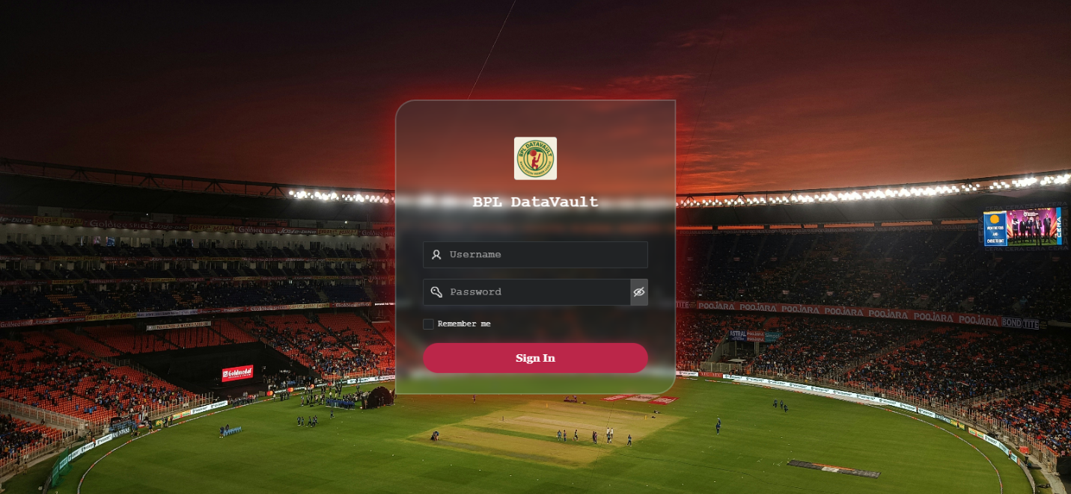

**Dashboard:** Home Page - 1

**Page2:** Ball_By_Ball Report Page

**Page3:** Ball_By_By Form Page

**Page4:** Extra Runs Report Page

**Page5:** Extra Runs Form Page

**Page6:** Match Report Page

**Page7:** Match Form Page

**Page8:** Match Result Report Page

**Page9:** Match Result Form Page

**Page 10:** Player Report Page

**Page 10:** Player Form Page

**Page 12:** Scored Runs Reports Page

**Page13:** Scored Runs From Page

**Page 14:** Season Report Page

**Page15:** Season Form Page

**Page16:** Season Team Player Report Page

**Page17:**Season Team Player Form Page

**Page18:** Team Report

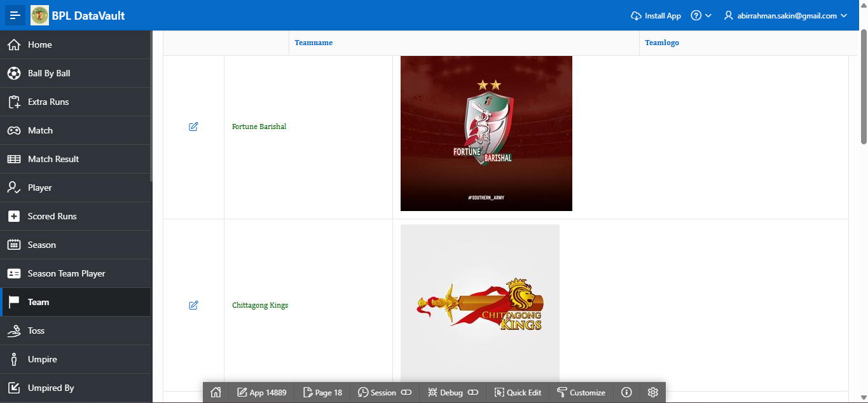

**Page19:** Team form page

**Page20:** Toss Report

**Page21:** Toss Form Page

**Page22:** Umpire Report Page

**Page23:** Umpire Form

**Page24:** Umpired By Report page

**Page25:**Upmired by Form Page

**Page26:** Venue Report Page

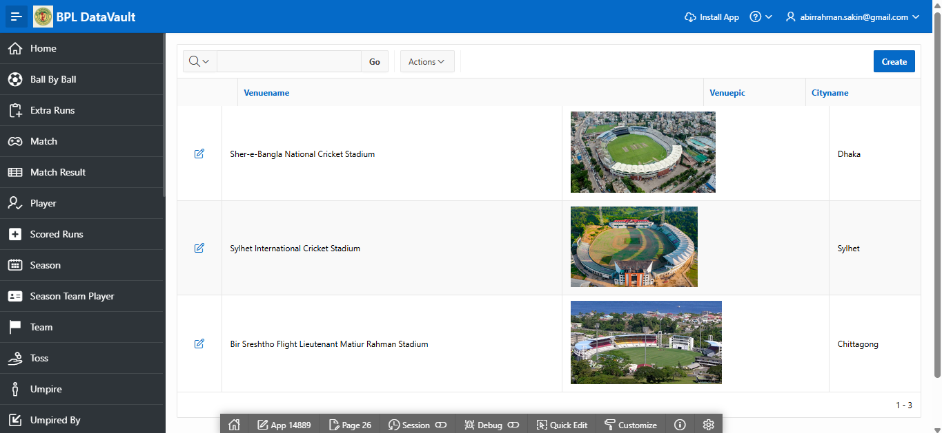

**Page27:**Venue Form Page

**Page28:** Wicket Taken Report Page

**Page29:** Wicked taken Form Page

|  |  |  |
| --- | --- | --- |
| **Page Number and Name** | **Query Type** | **Report description** |
| 30. Batting Statistics | Multi-table and  Aggregate | This page is based on  Query, Displays the  Batting statistics of all players , And a bar chart of top 10 run scorers. |
| 31. Bowling Statistics | Multi-table and  Aggregate | This page is based on Query. Displays all bowlers ever bowled in IPL ,and their career Statistics . Added a bar chart to Show top ten bowlers. |
| 32. Team Statistics Over  season | Multi-table and Aggregate | Team Statistics Over ALL Season |
| 33. Chased Above 180  runs | Multi-table and  Aggregate | ALL matches chased over 180 runs scored in first innings |
| 34. Batting average per venue | Multi-table and Aggregate | Batting average in each venue |
| 35. Highest innings in a match | Multi-table and  Aggregate | Highest total in a match |
| 36. Bowlers with most wickets | Multi-table and Aggregate | Bowlers who got most wickets in each season |
| 37. Most sixes in each season | Multi-table and  Aggregate | Batters who hit most sixes in each season |
| 38. Top win ratio | Multi-table and  Aggregate | Top5 Teams with most win ratio across season |
| 39. Toss Impact in a match | Multi-table and  Aggregate | Toss Impact in a match across all seasons. Toss' decision led to winning records. |
| 40. Most MOTM | Aggregate | Most MOTM in each season |
| 41. Match Wasted in D/L method | Aggregate | Match Wasted in D/L method in each season |

**Page30:** This page is based on Query, Displays the Batting statistics of all players , And a bar chart of top 10 run scorers.

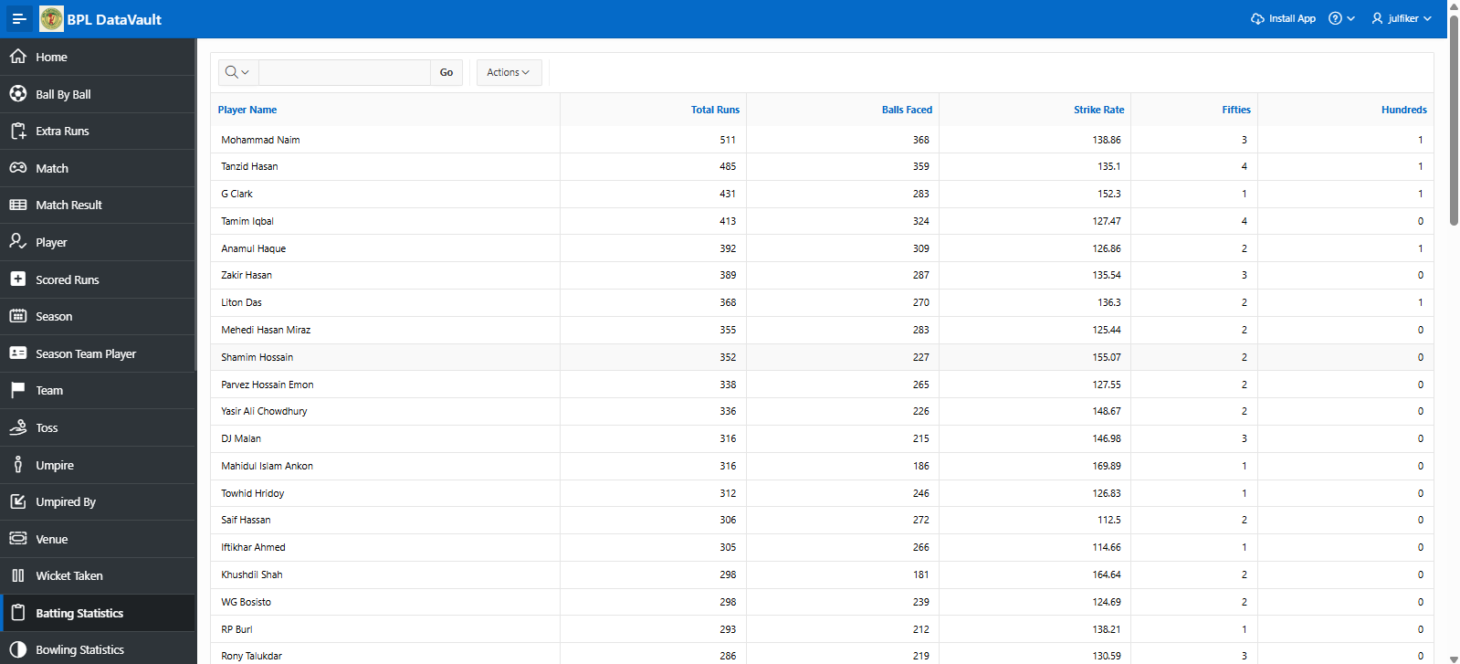

**Page31:**This page is based on Query. Displays all bowler ever bowled in BPL and their career Statistics . Added a bar chart to Show top ten bowlers.

**page32:** Team Statistics Over ALL Season

**Page33:** ALL matches chased over 180 runs scored in first innings

**Page34:** Batting average in each venue

**Page35:** Top 5 Highest innings in a match

**Page36:** Bowler with most wickets

**Page37:** Most sixes hit by a player in each season

**Page 38:** Win ratio of all team

**Page39:** Toss Impact in a match

**Page40:** Most Man of the match award

**Page41:** Matches which end up in D/L method

|  |  |
| --- | --- |
| **Page number & Charts** | **Chart description** |
| 42. Worst Statistics | Worst Records:  Top10 Batters with most DUCKs  Top 5 Safe hands  Top 5 Bowlers with extra runs  Top5 Bowlers with worst economy |

**Page42:** Worst Records

|  |  |  |
| --- | --- | --- |
| **Page & Name** | **Master(Parent)** | **Details(Child)** |
| 43. Season wise Match | Season | Match |
| 44. Match in Venue | Venue | Match |

**Page43:** Season wise match details

**Page 44:** Match Statistics in all venues.

**Authorization and User Role Assignment:**

|  |  |  |
| --- | --- | --- |
| **UserName** | **Password** | **Role** |
| abirrahman.sakin@gmail.com | #spsakin@329 | Administrator |
| sudeep | sheep | Administrator |
| julfiker | monkey | Administrator |
| sakin | lion | Administrator |
| rashed | rashed | Administrator |
| thor | loki | Contributor |
| messi | goat | Reader |
| neymar | goat | Reader |
| ronaldo | goat | Reader |

**Page-wise Authorization Information**

|  |  |
| --- | --- |
| **Page number and name** | **Authorization Level** |
| 10000 | Administrator |
| All the pages (expect Create , Delete, Update & Save button) | Reader |

**Page:1000** [Administration Page]

**Conclusion:**

This project was both a challenging and rewarding experience that pushed us to grow both technically and intellectually. It deepened our understanding of database management principles, from designing efficient schemas to writing complex queries and ensuring data integrity. Along the way, we encountered several obstacles that required critical thinking and creative problem-solving, which ultimately strengthened our analytical abilities. Beyond the technical aspects, this journey taught us the importance of patience, persistence, and continuous learning—skills that we will carry forward into future projects and professional endeavors.

**The end**